Assignment 2

Ozzzi2p

2

**Feed Efficiency Exercise (3 marks)**

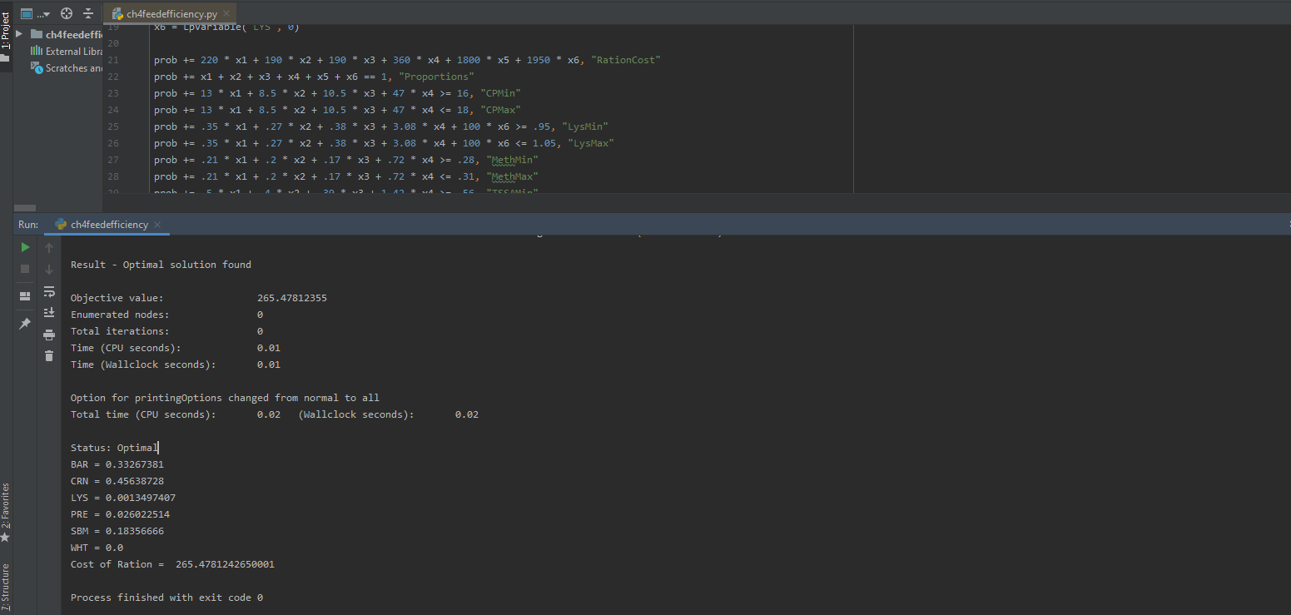

**Feed Efficiency Exercise (3 marks)**

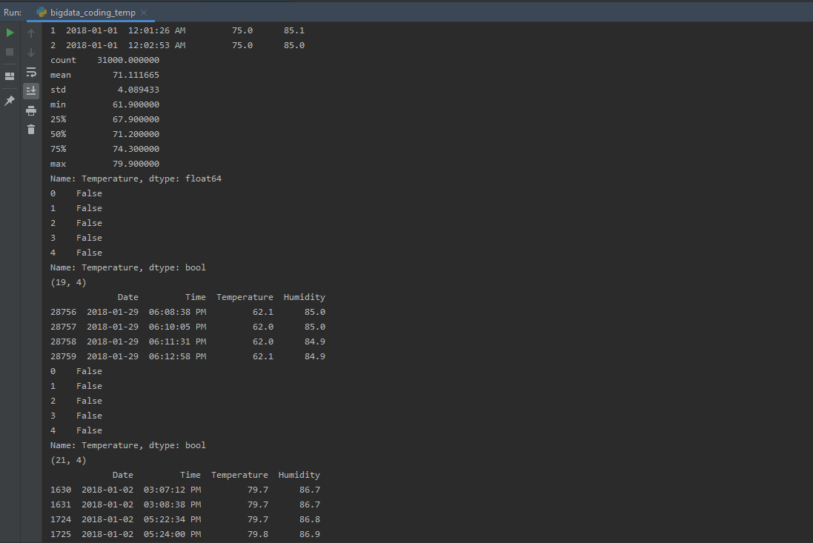

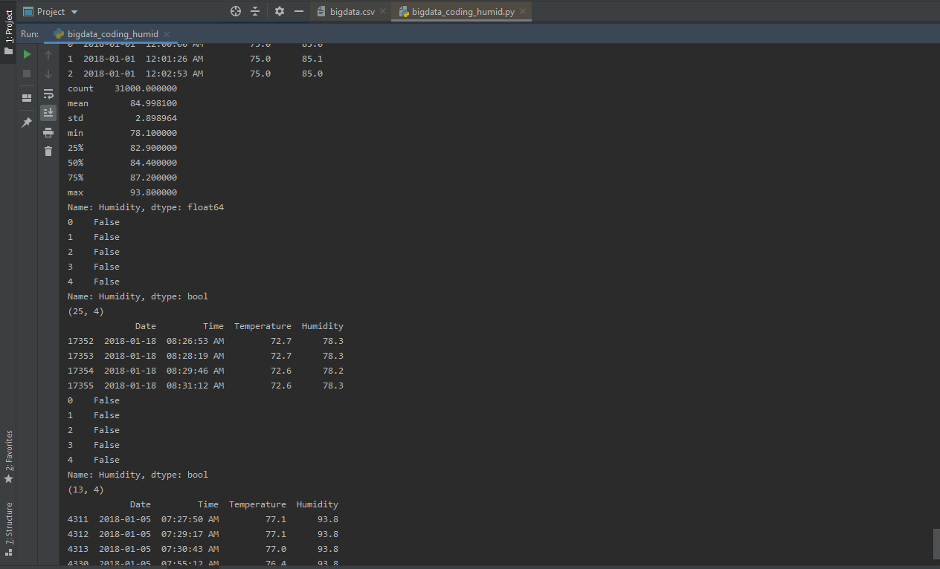

**Python Coding 2 Exercise (4 marks)**

